Music Player – Design Document by Artur Kondratiuk

1. Sketches

Library Page:
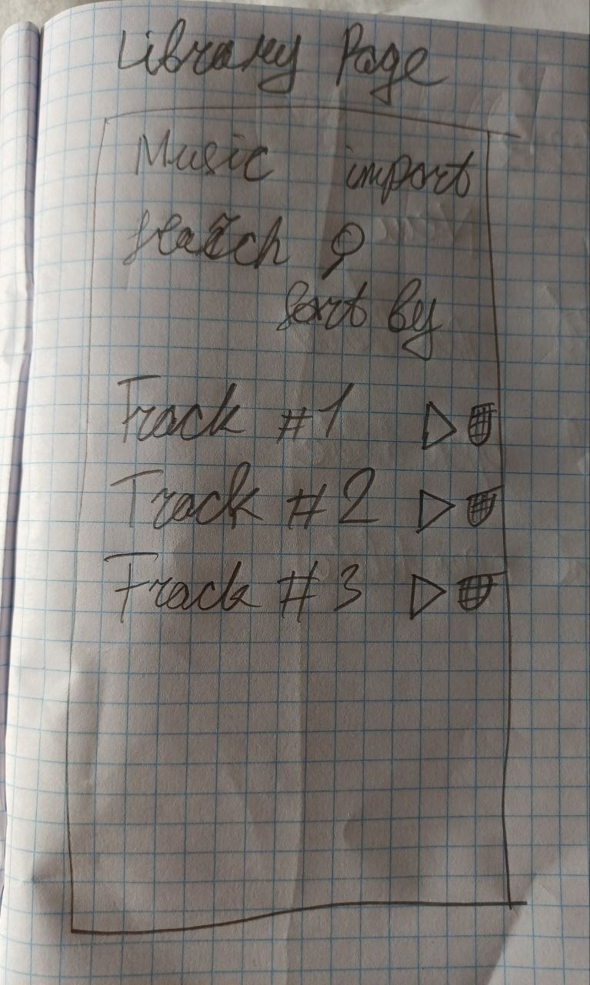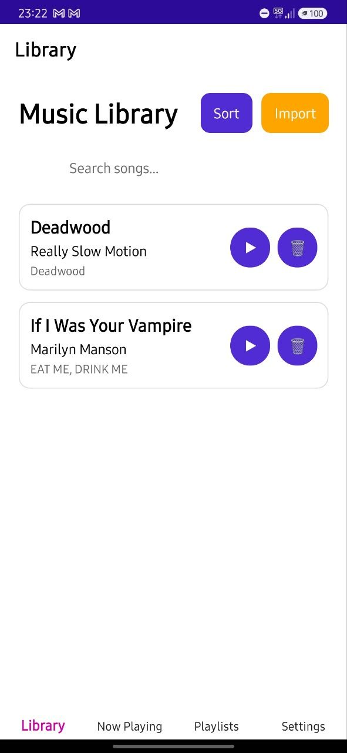
The design had to be simple and convenient, initially I wanted to place the sort button at the bottom under the search bar, but then I realized that it seemed better to the right of the page title with the import button, but otherwise the design remained the same as originally planned.

Now Playing Page:
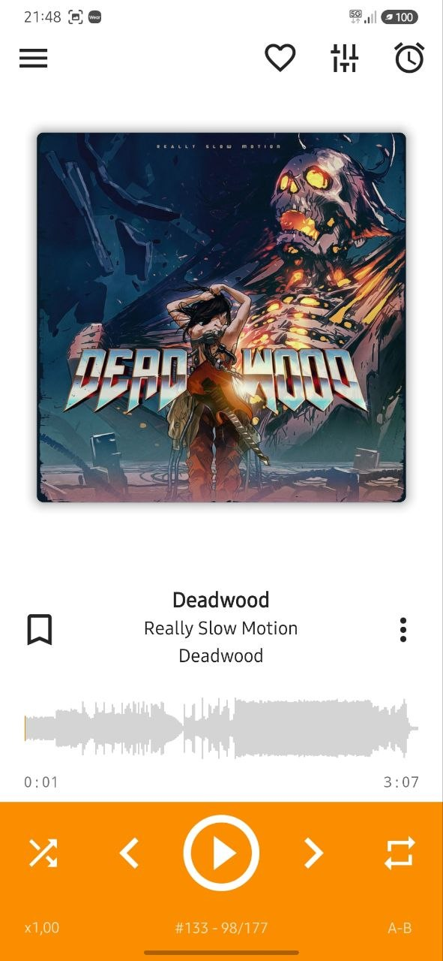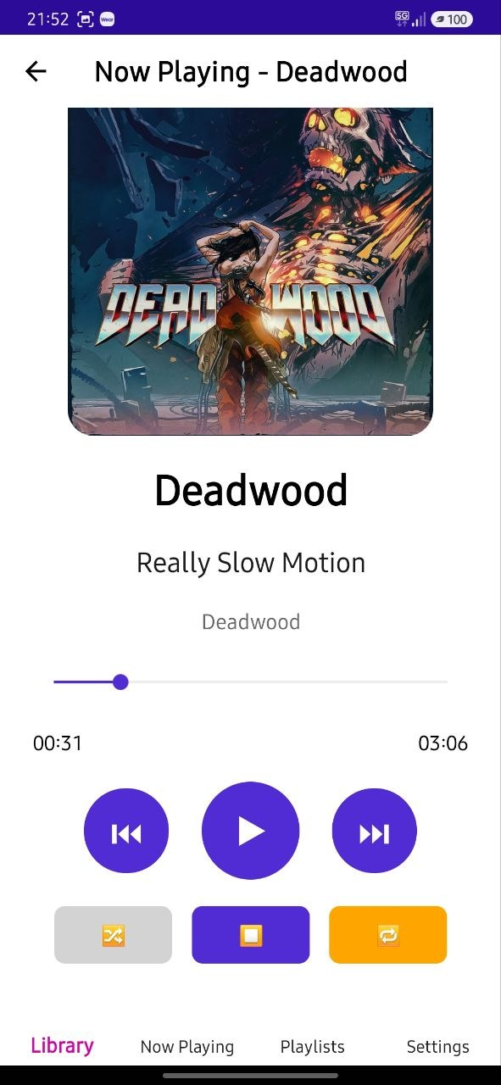
Before starting development, I had experience using several MP3 players, with AIMP being my favourite. It was a small design reference for my project, especially for the Now Playing page. However, AIMP works quite differently internally, so I only used it as a visual and functional inspiration rather than trying to reproduce it.

Playlists Page:
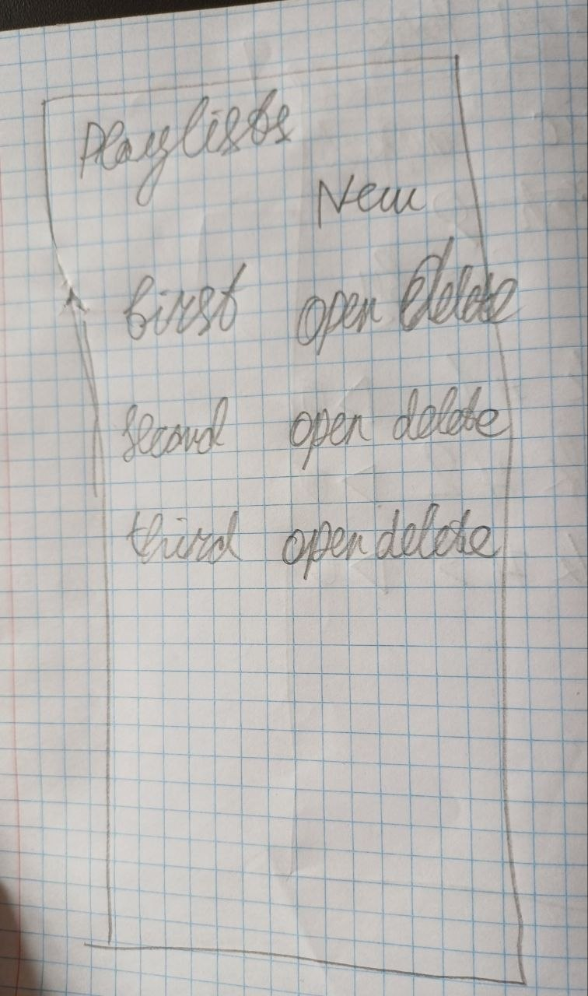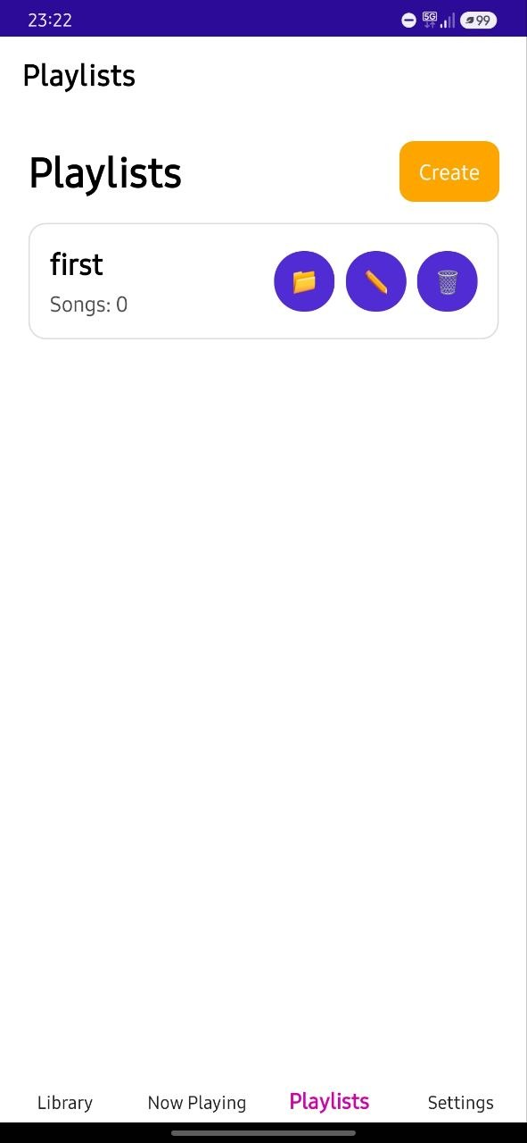
Initially, I thought of doing literally the same thing as LibraryPage, and in general it turned out that way, but a little later I replaced the open & delete text with emoji (same as on LibraryPage), added a count of songs in the playlist, and added a rename button.

Add Songs Page:
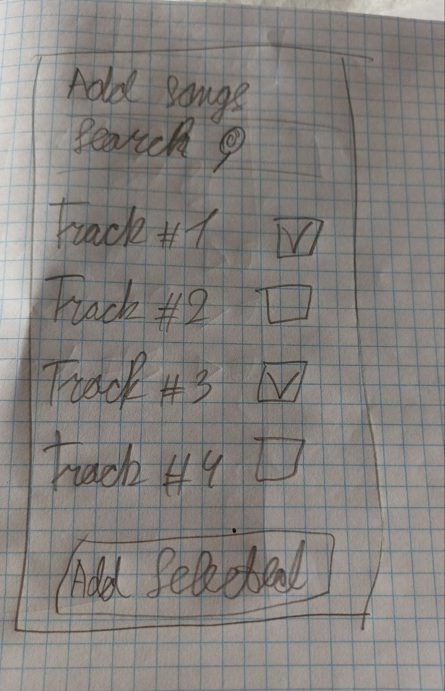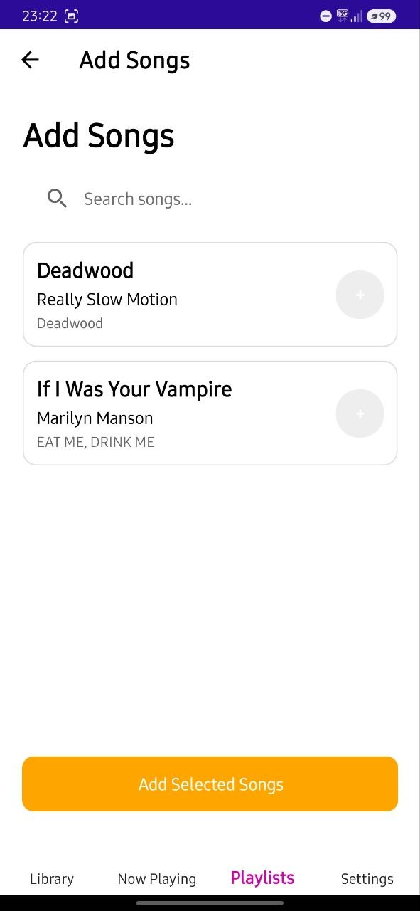
Initially, I wanted there to simply be a square opposite the track and the user could put a checkmark there, but later I found a way and was able to implement this system more beautifully - a circle with a plus, when clicked, it changes color and changes the plus to a checkmark, in general the same thing but it looks more beautiful and not so clumsy.

Settings:
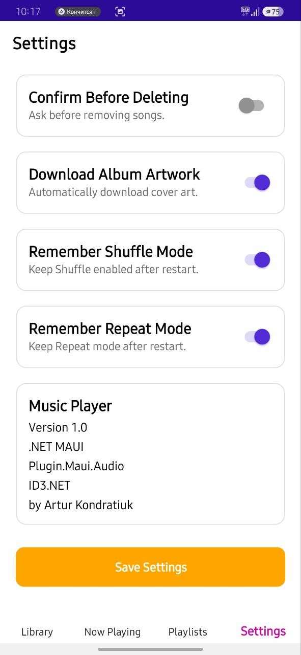
I didn’t draw a sketch for this page because I didn’t see the need, since this page was needed only to cram into it the simplest settings that I could implement. The only thing I kept in mind was that I wanted there to be a plate at the bottom with these applications and the software on which it was developed, and a button to save settings.

2. Application Structure
The application consists of six pages, each responsible for a specific part of the program.
- LibraryPage (main page) – displays all imported songs stored in the music library. Users can import new songs, search the library, sort songs by title, artist or album, play a selected song and remove songs from the library. The page also displays an empty state when no music has been imported.
- NowPlayingPage – displays the currently playing song together with its album artwork, title, artist and album information. It also contains all playback controls including play/pause, previous, next, stop, shuffle, repeat, progress slider and volume control.
- PlaylistsPage – allows users to create, rename and delete playlists. Each playlist displays its name together with the number of songs it contains.
- PlaylistDetailsPage (opened from PlaylistsPage) – displays every song inside the selected playlist. From this page the user can play songs, remove songs from the playlist or navigate to the Add Songs page.
- AddSongsPage (opened from PlaylistDetailsPage) – displays songs from the music library that are not already part of the selected playlist. Users can search the library, select multiple songs and add them to the playlist.
- SettingsPage – allows users to customise the application. Settings include dark mode, default library sorting, delete confirmation, automatic album artwork download, remembering shuffle mode and remembering repeat mode. All settings are saved locally and restored when the application starts.
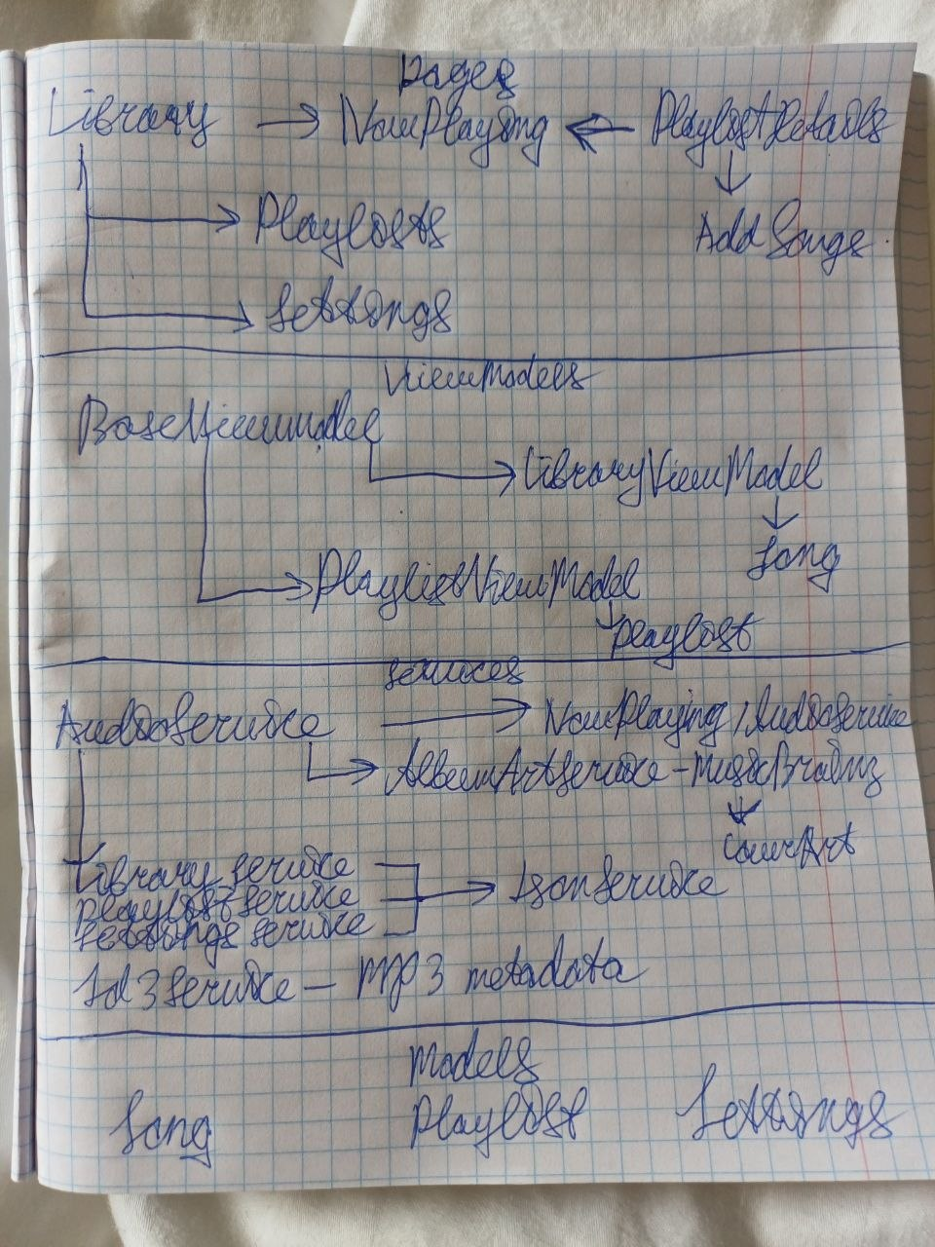
The project is organised into four main parts:

Models
The Models folder contains classes that represent the application's data:
- Song – stores information about a music file, including its path, title, artist, album and album artwork URL.
- Playlist – stores the playlist name and its collection of songs.
- Settings – stores user preferences such as theme, sorting options and playback preferences.

Services
The Services folder contains most of the application's logic.
- AudioService manages music playback using the Plugin.Maui.Audio library. It also controls playback state, shuffle, repeat, volume and playback position.
- LibraryService loads and saves the music library.
- PlaylistService loads and saves playlists.
- SettingsService loads and saves application settings.
- JsonService provides generic methods for reading and writing JSON files.
- Id3Service reads metadata such as song title, artist and album from MP3 files.
- AlbumArtService downloads album artwork using the MusicBrainz and Cover Art Archive APIs and stores downloaded results in memory to avoid unnecessary network requests.

ViewModels
The ViewModels folder provides observable collections used by the user interface.
- BaseViewModel implements property change notifications.
- LibraryViewModel stores the collection of songs displayed in the library.
- PlaylistViewModel stores the collection of playlists displayed in the playlists page.

Pages
The Pages folder contains the user interface, and logic for it, while most of the application logic is delegated to the service classes.
Application data is stored locally in three JSON files (library.json, playlists.json, settings.json). When music is imported, Id3Service extracts the metadata before LibraryService saves the songs. During playback, AudioService manages the current playlist and updates the NowPlayingPage. Playlist information is stored separately and references songs that already exist in the music library.

3. Design Decisions
- Library as the main page – The Library page is the main starting point because the user can immediately see their imported music, search for songs, sort them and start playback.
- Empty states – I added dedicated empty states instead of leaving pages blank. For example, the library shows a welcome message when there are no songs, while search shows a different message when no results are found. Playlists also have an empty state explaining how to add songs.
- Search and sorting – I added search by title, artist and album, as well as sorting by these fields. The selected sorting option is saved in the settings so it is remembered.
- Playlists are separate from the library – Playlists do not contain separate copies of music files. They reference songs already imported into the library. This avoids unnecessary duplication.
- ID3 metadata – When music is imported, the application reads the song title, artist and album from the MP3's ID3 tags. If metadata is missing, default values such as Unknown Artist and Unknown Album are used (AlbumArt too).
- Automatic album artwork – It first searches using the artist and album, and if that fails it searches using the song title. The feature can be disabled in Settings. Also, the cover is cached in library.json so that the request is not sent again and the cover loads faster.
- Shuffle and repeat modes – The player supports normal playback, shuffle, repeat-all and repeat-one. I also added options to remember shuffle and repeat settings between application launches.
- Settings page – User preferences such as dark mode, sorting, delete confirmation, album-art downloading and playback modes are grouped into one settings page instead of being scattered throughout the application.
- Animations – Pages and some player controls use small animations when appearing or being pressed. These are intentionally short so they make the application feel more responsive without slowing down normal use.
- Dependency injection – Services such as AudioService, LibraryService, PlaylistService and SettingsService are registered in MauiProgram. This makes the main services available to the pages without creating all of them manually. (cool)
- Event-based player updates – AudioService raises events when playback position or the current song changes. NowPlayingPage listens to these events and updates the interface.

4. What Works (From the requirements)

Works
- Data Binding
- viewable on Windows and Android UI
- Little animations
- Dark/light mode
- Preferences relevant to Music Player
- Saving data to Json
- Plugin.Maui.Audio
- User can open files from his devices
- User can picked songs from his saved library
- Reading ID3 tags to display metadata
- Support Playlists: create, rename, delete, add songs from library
- NowPlayingPage display current song’s metadata
- NowPlaying state persist across navigation
- Display the Album Art
- All playback controls
- Library filtering (search bar and sorting)
Not works
- Font sizes – didn’t do
- Colour themes – didn’t do
- Folder scanning – didn’t do (Folder scanning – not implemented. I could not find a suitable cross-platform solution for Android. I contacted the teacher about using an additional CommunityToolkit plugin, but did not receive a response, so I decided not to add an unconfirmed dependency)

5. Testing
Platform | Result
Windows 11 | Tested
Android Device (Samsung A34) | Tested
The following functionality was tested on both platforms:
- importing music;
- sorting;
- playing songs;
- playlist management;
- searching;
- settings;
- dark mode.
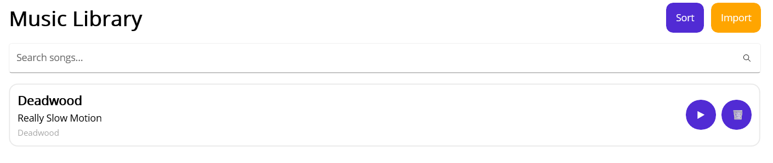
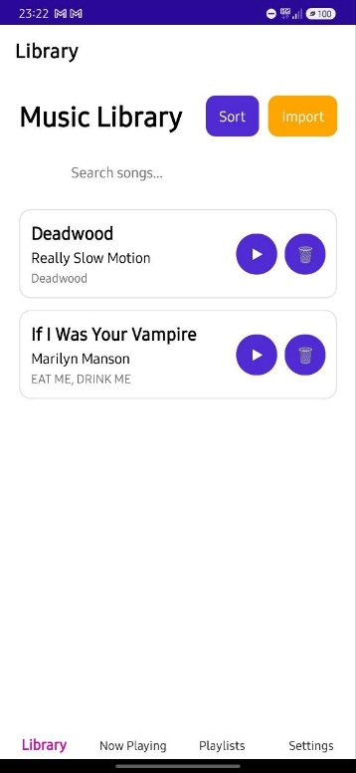

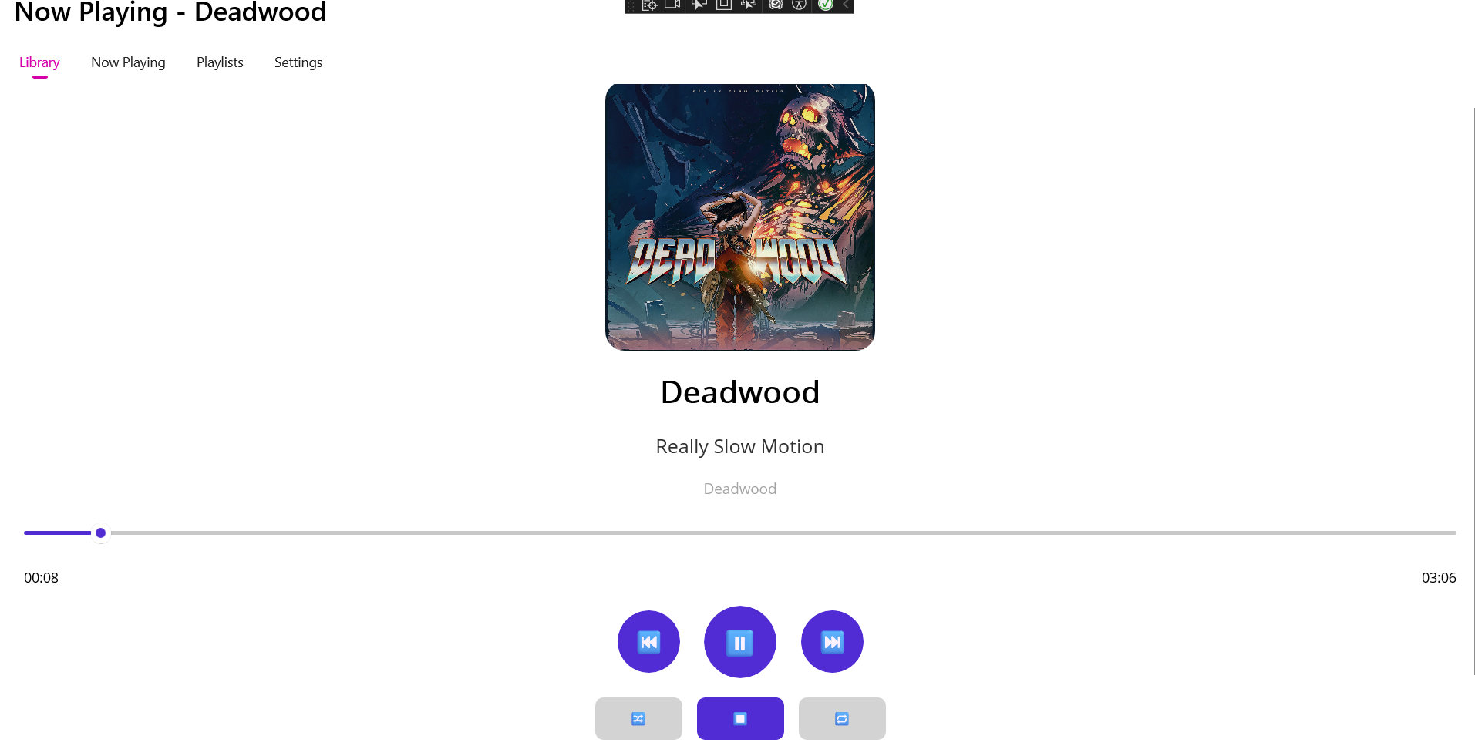


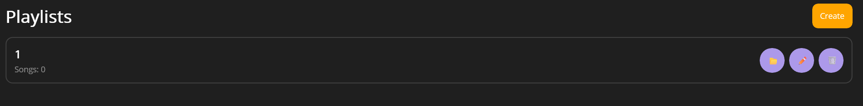
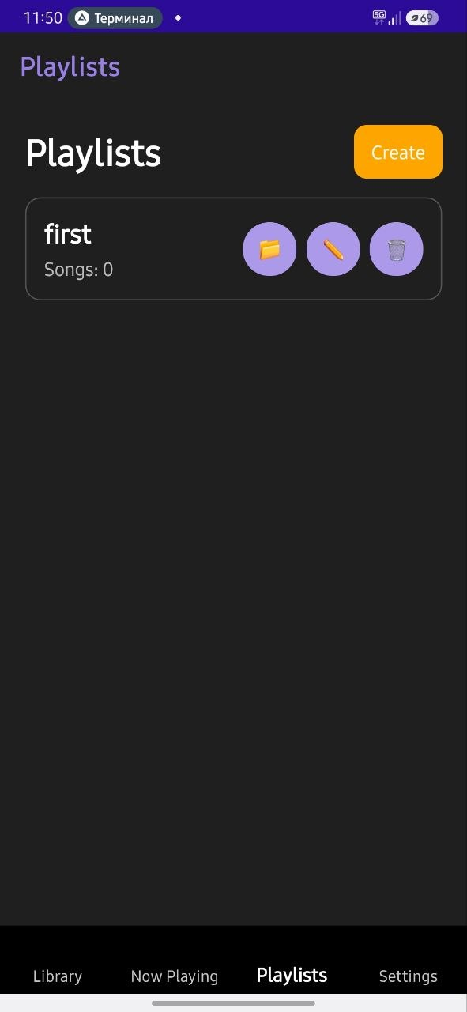

The only thing I found that seemed strange to me was that some covers are loaded on Android, and some are not, while in the meantime all of them are loaded on Windows. I tried to look for the problem and spent a lot of time, but all I could understand is that MusicBrainz responds equally well to the request, and the cover is there, but for some reason it is not displayed,
again only in some cases. I can only assume that some covers are too big and weigh a lot, and the UI simply cannot display it on Android, but this is my only guess, but I have no idea how to fix it.

